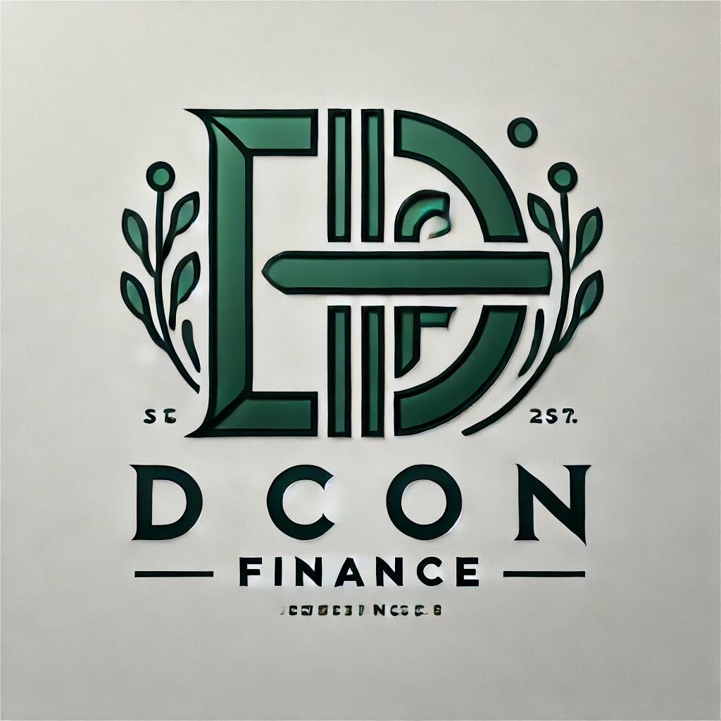

DICON FINANCE

Fixed Deposit Application Form

Applicant Information
- Title:
- Gender:
- First Name:
- Middle Name:
- Last Name:
- Date of Birth:
- Email:
- Phone Number:
- NIN / SSN:
- Address:
- City:
- State:

Fixed Deposit Details
- Deposit Amount (₦ / $):
- Deposit Amount in Words (₦ / $):
- Tenure (Months):
- Interest Rate (%):
- Maturity Date:
- Interest Payment Option (Monthly / At Maturity):

Next of Kin Information
- Title:
- Gender:
- First Name:
- Middle Name:
- Last Name:
- Relationship:
- Email:
- Phone Number:
- Address:
- City:
- State:

Bank Details for Interest Payment
- Account Name:
- Bank Name:
- Bank Account Number:
- BVN / NIN / SSN:

Declaration
I hereby confirm that the information provided above is true and correct to the best of my knowledge. I agree to the terms and conditions governing this fixed deposit with Dicon Finance.
Applicant’s Signature: ___________________________ Date: _______________
Authorized Officer Signature: _____________________ Date: _______________
Motto: Empowering Your Dreams, Financing Your Future.

